Ingredients  1 cup LSA (Linseed, Sunflower seeds and Almond Meal) mix  2 ½ cup self raising flour  1 cup sugar  1 cup vegetable oil  ½ tps salt  ¼ cup of milk for pattern on cookies |  | LSA cookies  Linseed Sunflower Almond Cookies  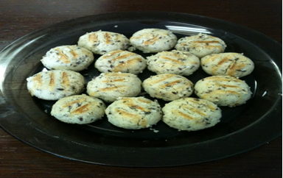  Method  - Combine all ingredients in a mixing bowl. (If too dry, add more oil and too wet, add more self raising flour)  - Line a baking tray with grease proof paper  - Take a spoonful of the mixture and roll into a ball  - Place the ball onto the tray, leaving a gap between each ball  - Dip a fork into milk then lightly press onto the ball (flattening it slightly) to make a pattern  - Bake the cookies for 15 mins at 180C, or until slightly golden brown.  - Remove and place on a cooling rack to cool

