Mindfulness Art &Crafts Series (June to October 2015)
禪心巧藝系列 (2015 年6月至10月）

Program （课程）
- Mindfulness Art &Crafts Series- Floral Arts Workshop (20/6/2015)

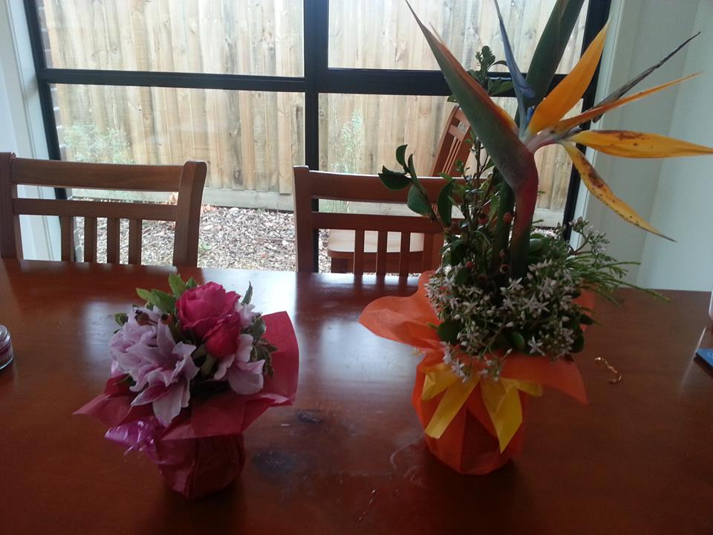

In this workshop, you will be shown how to make a few bouquets of flowers. The concept of mindfulness upheld in a sitting meditation practice can be incorporated into the flower arrangement process where you are fully aware of all the steps and enjoy every moment of the creation. At the end of the workshop, you will bring home a bouquet or two uniquely made by yourself. We will use recycled materials such as jars, bottles, paper and ribbons. If you can bring some flowers from your own garden, it will be more meaningful for you.

- 禪心巧藝系列- 花解语工作坊(20-6-2015)
此工作坊將會教大家制作花束及插花。 正所谓‘行住坐卧，無不是禪’，除了打坐， 禅修的概念也都可以延伸到我們生活上。 希望参与者可以用一颗禪修的心來享受制作花束及插花的過程及乐趣。工作坊结束后，每個参与者都可以将自己制作獨一無二的花束带回家。此工作坊秉持环保概念，將會采用再循环资源，如各种瓶瓶罐罐及包装纸及丝带。 若家里花園有漂亮花朶，不妨带来与大家分享结缘。

- Mindfulness Art &Crafts Series- Doll Making Workshop (18-7-2015)

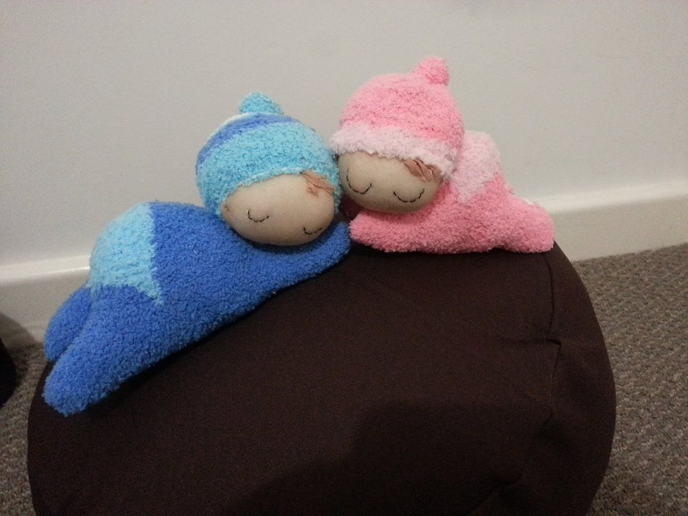

In this workshop, you will be shown how to make a fluffy and cute baby doll. The concept of mindfulness upheld in a sitting meditation practice can be incorporated into the doll making process where you are fully aware of all the steps and enjoy every moment of the creation. At the end of the workshop, you will bring home a doll uniquely made by yourself.

2.禪心巧藝工作坊---胖娃娃制作工作坊 (18-7-2015)
此工作坊將會教大家制作一個胖胖的小娃娃。正所谓‘行住坐卧，無不是禪’，除了打坐， 禅修的概念也都可以延伸到我們生活上。希望参与者可以用禪修的心來享受制作娃娃的乐趣。工作坊结束后，每個参与者都可以将自己制作獨一無二的娃娃带回家。

- Mindfulness Art &Crafts Series--- Fabric and Ribbon Arts Workshop (15-8-2015)

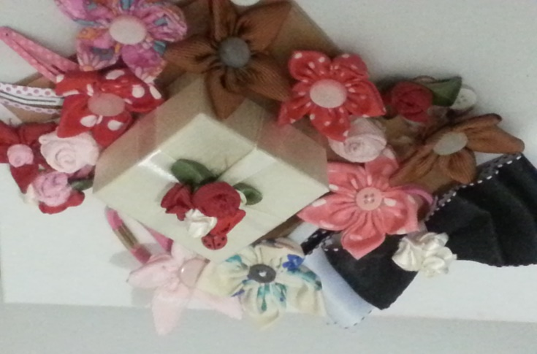

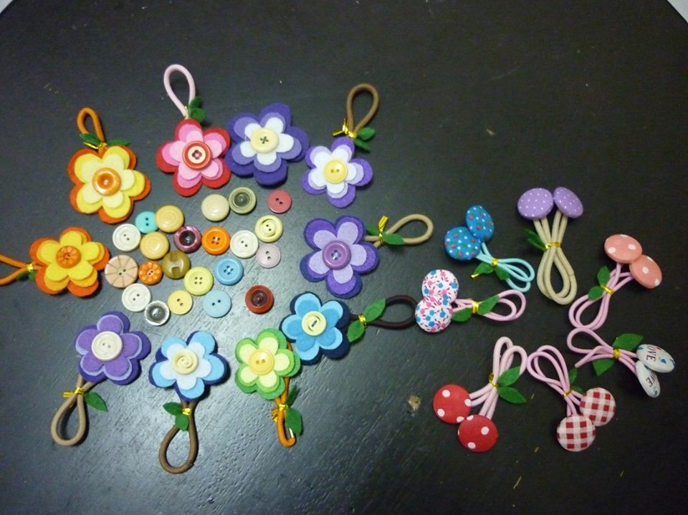
In this workshop, you will be shown how to make flowers with fabric and ribbons. These little flowers can be used to make hair and fashion accessories, brooches, gift boxes and many others. The concept of mindfulness upheld in a sitting meditation practice can be incorporated into the crafting process where you are fully aware of all the steps and enjoy every moment of the creation. At the end of the workshop, you will bring home creations uniquely yours. This workshop encourages the use of recycled materials such as fabric, ribbons, buttons and hair clips.

3.禪心巧藝系列- 花物语工作坊 (15-8-2015)
此工作坊將會教大家制作各种缎带花藝。并用这些小花再制作成各种髮饰，衣饰，胸针，及小礼盒。 正所谓‘行住坐卧，無不是禪’，除了打坐， 禅修的概念也都可以延伸到我們生活上。 希望参与者可以用一颗禪修的心來享受制作過程及乐趣。工作坊结束后，每個参与者都可以将自己的作品带回家。此工作坊秉持环保概念，將會采用再循环资源，如各种布料，丝带， 小盒子等。

- Mindfulness Art &Crafts Series---Key-pouch & key-ring Making Workshop (19-9-2015)

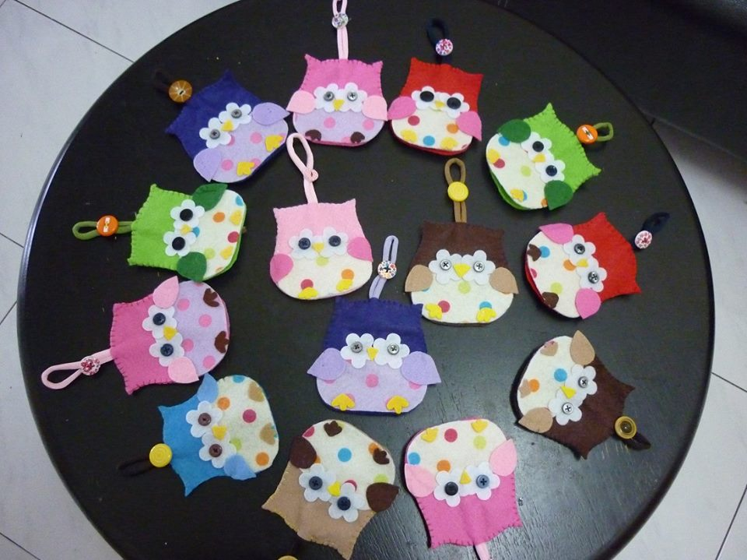

In this workshop, you will be shown how to make key pouches and key rings using felt and other materials. These little knick knacks can be wonderful gifts for friends and relatives. The concept of mindfulness upheld in a sitting meditation practice can be incorporated into the crafting process where you are fully aware of all the steps and enjoy every moment of the creation. At the end of the workshop, you will bring home your creations. This workshop encourages the use of recycled materials such as felt, fabric, ribbons and buttons.

4.禪心巧藝系列- 小玩意制作工作坊 (19-9-2015)
此工作坊將會教大家制作各种钥匙圈及钥匙包等小玩意。正所谓‘行住坐卧，無不是禪’，除了打坐， 禅修的概念也都可以延伸到我們生活上。 希望参与者可以用一颗禪修的心來享受制作過程及乐趣。工作坊结束后，每個参与者都可以将自己的作品带回家。此工作坊秉持环保概念，將會采用再循环资源，如各种布料，丝带及纽扣等。

- Mindfulness Art &Crafts Series---Halloween Crafts Making Workshop (17-10-2015)

This workshop is specially designed for children between 7 and 12 years old and their parents. Participants are taught to make Halloween crafts which they can play with. In the crafting process, the participants are taught to feel the materials, get materials organized and create something out of those materials. Children are also asked to pay attention to their breathing and feelings in the whole process--- whether they are frustrated or satisfied with what they have been doing. After the workshop, the participants can bring all their creations home. This workshop encourages the use of recycled materials such as felt, fabric, ribbons and buttons.

5.禪心巧藝系列---万圣节玩具制作工作坊 (17-10-2015)
此工作坊是专门为7至12岁的小朋友及家长们设计。此工作坊将教小朋友制作万圣节玩具。此工作坊首先让小朋友触摸各种材料，再教他们如何剪裁及制作玩具，也教小朋友在制作过程中注意自己的呼吸及情绪。 小朋友也可以在制作过程后分享自己的感受。工作坊结束后，每个小朋友都可以把自己亲手制作的玩具带回家。此工作坊秉持环保概念，將會采用再循环资源，如各种布料，丝带及纽扣等。 这也是一项亲子活动，欢迎家长携带小朋友参加及体验亲手自作玩具的乐趣。

