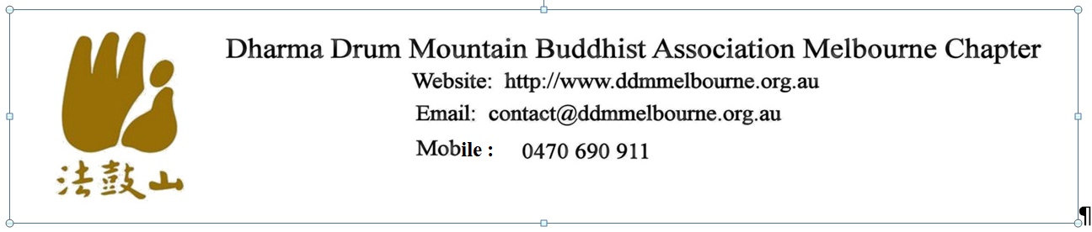
MEMBERSHIP FORM
I ………………………………………………………………………………………………………………………………………….of
First Name Last Name

……………………………………………………………………………………………………………………………………………...
(Address)

Email :………………………………………………………………….…Mobile: …….………………………………………….

supports the purposes* of the Association and wishes to become a member# of Dharma Drum Mountain Buddhist Association Melbourne Chapter Inc. In the event of my admission as a member, I agree to be bound by the Rules (see Committee & Rules on our website) of the Association.

………………………………………….…. ………………………………..
Signature of Applicant Date

I, …………………………………………….………… , a Committee member of the Association, nominate
(name of proposer)

the applicant, who is personally known to me, for membership of the Association.

……………………………………………. …………………………………
Signature of Proposer Date

Membership is $20/year (or $10/6 months)

*Purposes :
Support the Common Ethos of Dharma Drum Mountain:
- Our vision: to uplift the character of humanity and build a pure land on earth.
- Our spirit: to give of ourselves for the benefit of all.
- Our direction: to return to the original intention of the Buddha and work for the purification of the world.
- Our approach: to promote comprehensive education and extend loving care to all.
#Member : A regular participant of at least 12 months, or shorter at the discretion of the majority of the Committee.
------------------------------------------------------------------------------------------------------------------------------------------------------Fees ($........)rec’d by …………………………………..Cash/EFT……………(date) Membership approved……..………(date)

