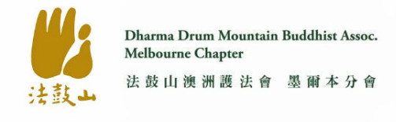
Address: Unit 1/ 38 McDowall Street, Mitcham VIC 3132
Mobile: 0470 690 911
Email : contact@ddmmelbourne.org.au

2024 March Activity Program 2024年3月活動表
Sun 3rd Mar | Meditation Group Practice 禪坐共修 | 10:30am – 12:30pm
 | Great Compassion Repentance Dharma Assembly  大悲懺共修法會 | 2pm - 4pm
Wed. 6th Mar | Chanting Amitābha Buddha Group Practice  念佛共修 | 10:30am -12:30pm
 | Dharma Instrument Practice 法器練習 | 1:30pm – 3:30pm
Sun 10th Mar | Meditation Group Practice 禪坐共修 | 10:30am – 12:30pm
Wed 13th Mar | Chanting Amitabha Buddha Group Practice  念佛共修 | 10:30am -12:30pm
 | Dharma Instrument Practice 法器練習 | 1:30pm – 3:30pm
Sun 17th Mar | Meditation Group Practice 禪坐共修 | 10:30am – 12:30pm
Wed 20st Mar | Bodhisattva Precepts Ceremony Group Practice  菩薩戒會誦戒儀共修 | 10:30am – 11:45am
 | Dharma Instrument Practice 法器練習 | 1:30pm – 3:30pm
Sun 24th Mar | Meditation Group Practice 禪坐共修 | 10:30am – 12:30pm
Wed 27th Mar | Chanting Amitabha Buddha Group Practice  念佛共修 | 10:30am - 12:30pm
 | Dharma Instrument Practice 法器練習 | 1:30pm – 3:30pm
Sun 31st Mar | Meditation Group Practice 禪坐共修 | 10:30am – 12:30pm

To keep all of us safe please

- stay at home if you are not feeling well, and
- wear a mask when attending the centre for activities

